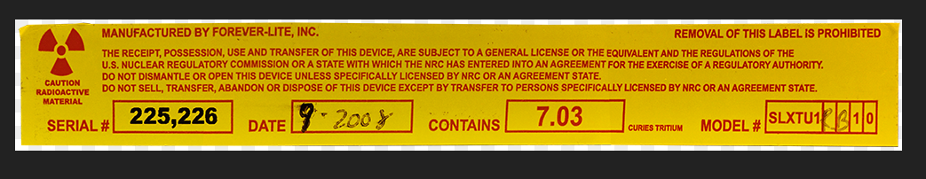
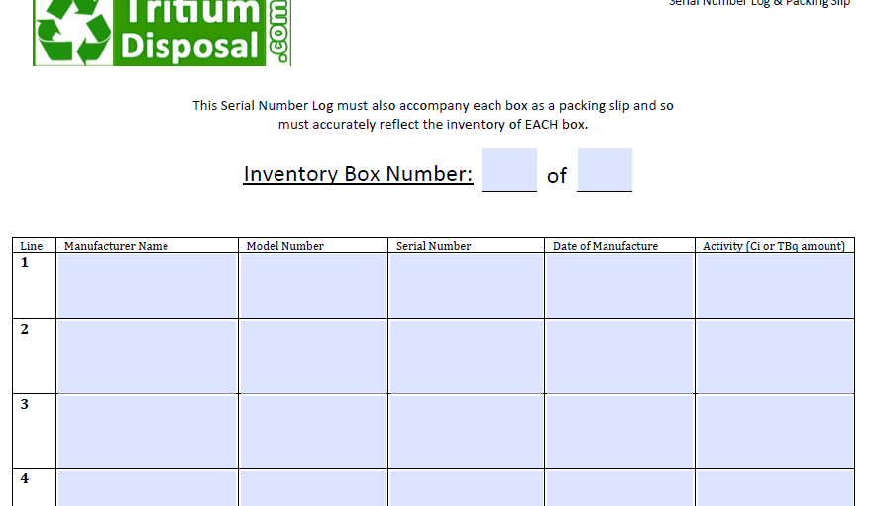

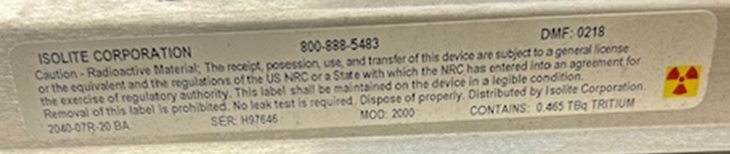

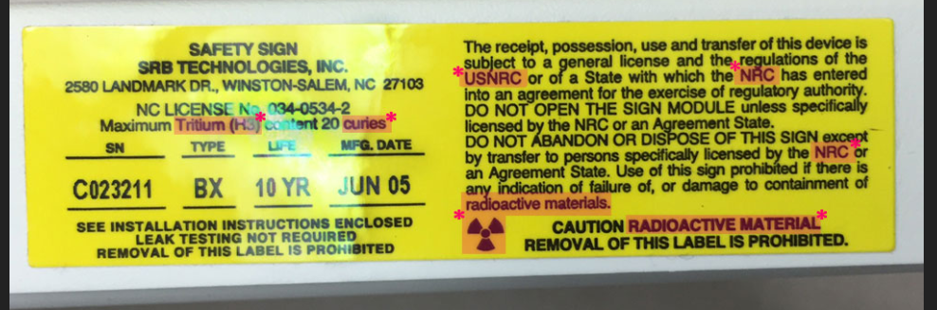

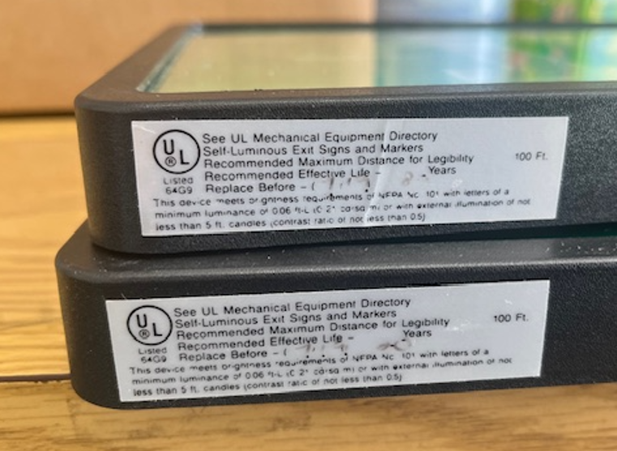
Serial # could have faded off. Back in the ‘90’s and early 2000’s, they were written by ink pen on the yellow sticker. Now they are printed along with the label and do not fade. They may be able to pop the frame and legend off and one may be on a yellow sticker on the face of the sign. That is how they are made and labeled currently. If they do not know the serial number and cannot find one, then they can just write unknown on the inventory sheet.

18.6
B100
SRB Technologies

